**Assignment 1 – Introduction to SQL**

**Problem Statement:**

Consider yourself to be Sam who is a student at a prestigious university. You have enrolled for the SQL course and it is your first semester.

**Tasks To Be Performed:**

1. Install MS SQL Server

Ans.: I’ve installed MS SQL Server in my system. Attaching screenshots for proof:

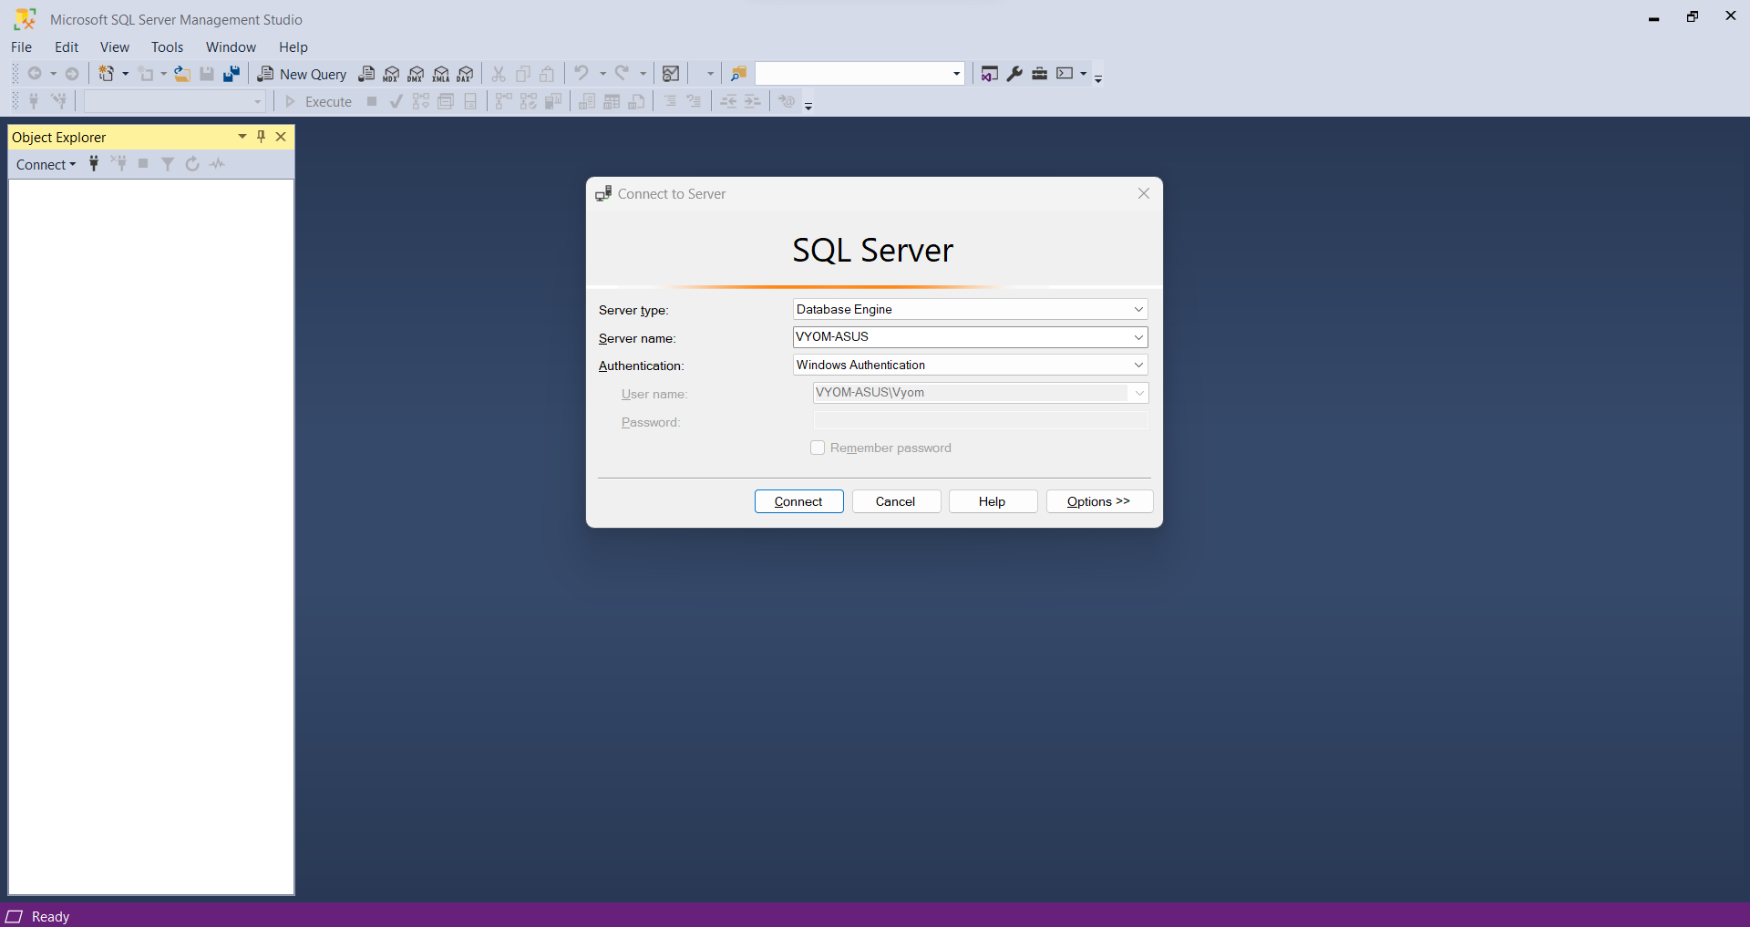

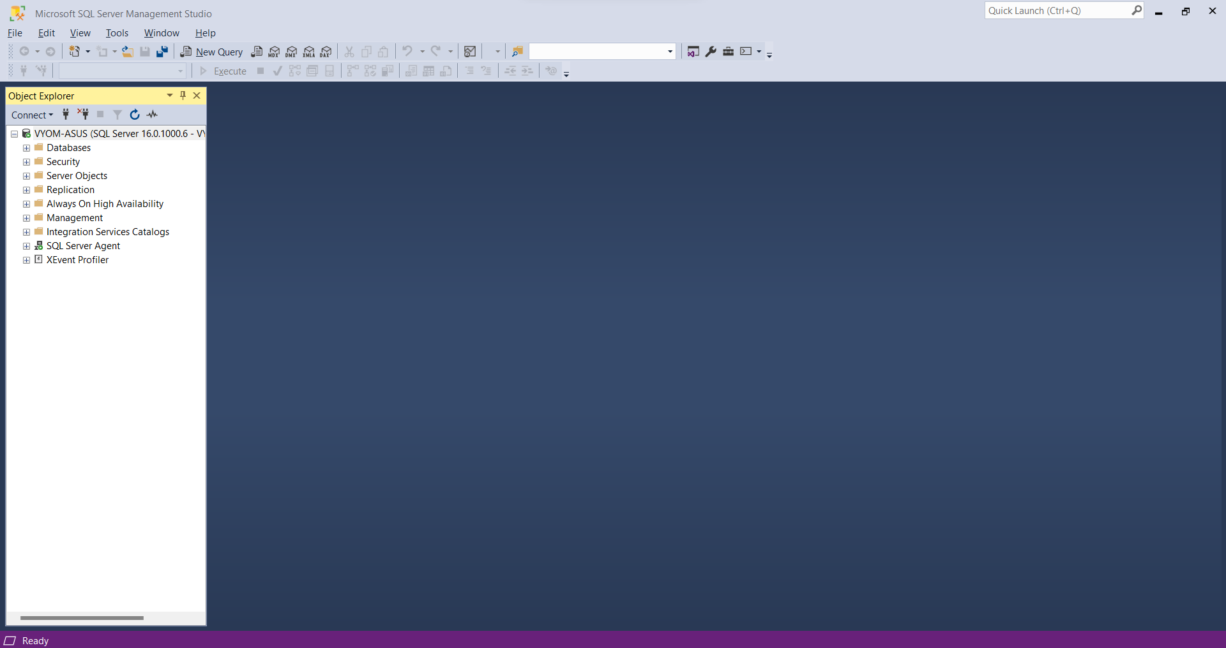

2. Give the difference between Char and Varchar data type.

Ans.: Both the data types store alphanumeric data. However, the difference between the 2 is that VARCHAR is variable length where as CHAR is fixed length. i.e., If a column is of datatype VARCHAR(6) it can hold alphanumeric data of a maximum length 6, where as a column of datatype CHAR(6) can only hold data of exactly length 6.

3. Explain the types of SQL Commands.

Ans.:

4. Explain NVarchar and Nchar.

Ans.: The NVarchar and Nchar characters also hold alphanumeric data, but they also support regional language characters. NVarchar. NVarchar can hold data of variable length whereas Nchar can hold data only of a fixed length.